15: Analyse Data with NumPy Part - 2

For this challenge, you are going to work with the data below. You are going to use NumPy functionality to answer questions using this data. This challenge will test your ability to use slicing to extract specific columns or rows of the data and perform operations on them. You will import a CSV file called names_age_sex_data.

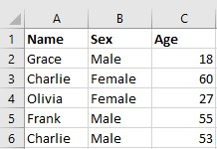

- Your task is to import the CSV file using NumPy’s genfromtxt() function.
  - Transpose the array.
  - Using slicing, create three arrays: an array of all the names in the column, an array of the age column, and an array of the gender (sex) column.
- Using NumPy, write code that returns all the names of people who are 56 years old.
- How many people are aged 44 or under?
- Write another code snippet to return an array of all the males in the dataset. How many males are in the dataset?
- Calculate the average age of all the females in the table.
- Calculate the average age of people named Olivia and Kate.

